**Exam ASSIGNMENT**

|  |  |
| --- | --- |
| **Module Name and Code** | **MS804 System development and project management.** |
| **Student Name and ID** | **Nirod kumar das (21240437)** |

1.

I. expected time of completion of each activity ET=(O+4r+P)/6

Where

o = optimistic completion time for an activity.

r = realistic completion time for an activity.

p = pessimistic completion time for an activity.

Expected time of completion of activity A=(2+4*3+4)/6= 3

Expected time of completion of activity B=(3+4*4+5)/6= 4

Expected time of completion of activity C=(1+4*3+5)/6= 3

Expected time of completion of activity D=(2+4*4+6)/6= 4

Expected time of completion of activity G=(2+4*6+10)/6=6

Expected time of completion of activity H=(7+4*12+17)/6=12

Expected time of completion of activity I=(1+4*3+5)/6=3

Expected time of completion of activity J=(2+4*4+6)/6=4

Expected time of completion of activity K=(1+4*3+5)/6=3

The same has been reflected in the table.

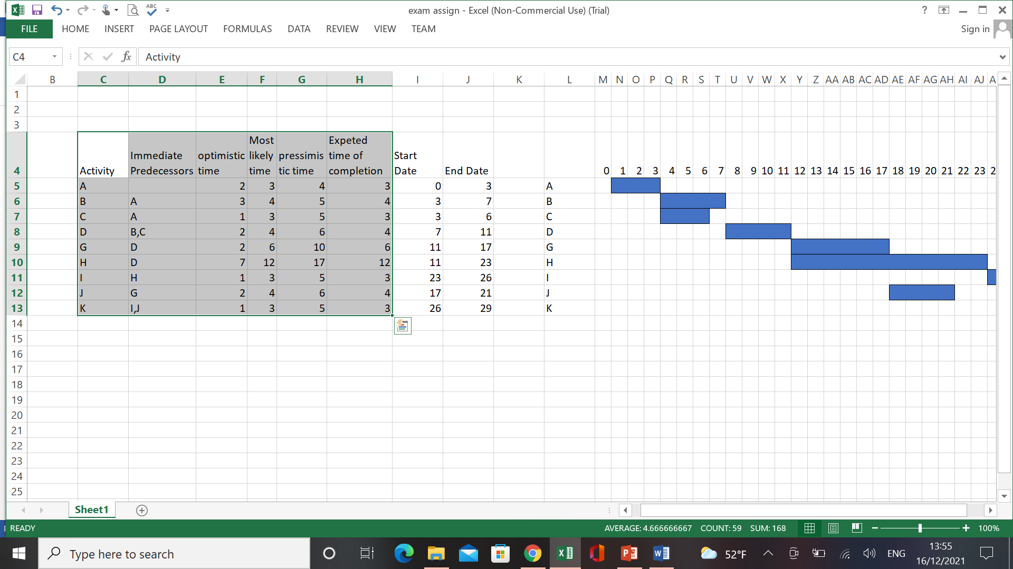

ii)Gantt chat

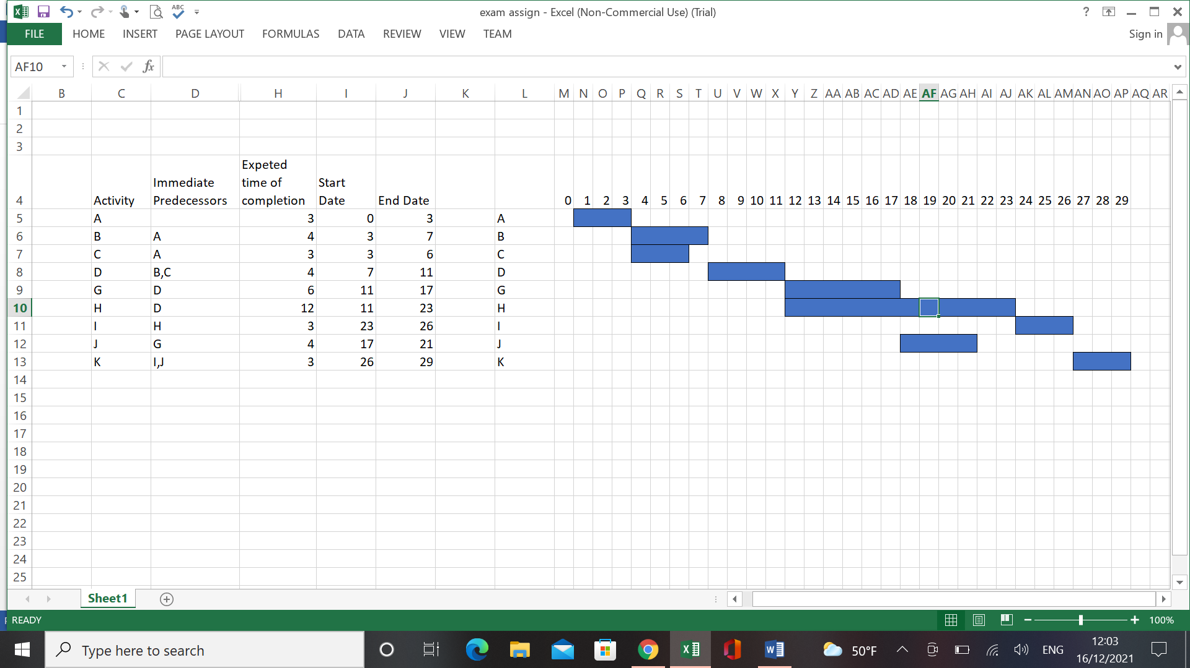

After calculating expected time of completion we calculated start day and end day considering all immediate predecessors activity starting from 0 .And as per the below Gantt chat has been made.



(Gantt Chat)

Iii )Network Diagram

considering all immediate predecessors activity the below network diagram has been made.

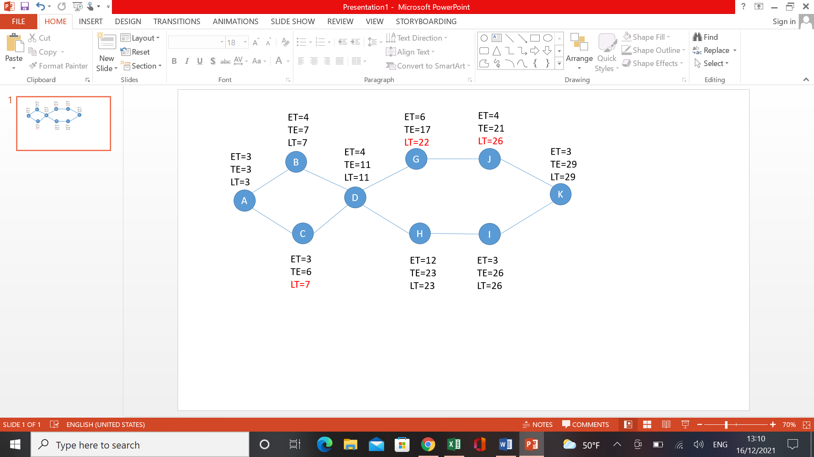

iv

Earliest expected time :

The Earliest expected time for A is 3 which is the starting point, As B starts after completion of A so for B 3+4= 7,As C is also starts after completion of A, so for C 3+3= 6,for D as it’s a must to finish activity B and C and B finishes at 7th day so for D 7+4=11, As activity G starts after activity D so for G is 11+6= 17 ,for H is 11+12=23 ,as activity I starts after completion of H so for I is23+3= 26 ,As J starts right after G so for J=17+4=21 and as K depends on activity J and I , but I finishes on 26 which is the highest among both ,so for K =26+3=29.

Latest Completion time :

For calculation of Latest completion time , the process been started from backward direction .As the project have to finish on 29th day so for K latest completion time is 29 .For I , J its reduced by 3 as that is the earliest expected time for K ,i.e. 29-3= 26 . For H it can be calculated as 26-3 = 23 and for activity G it is 26-4=22 .Both G and H can start after completion of activity D .so it is 23-12=11 ,it can’t be calculated from G as 22-6=16 and if it is so ,it will delay the whole project as activity H will be delayed. For activity B and activity C it can be calculated as 11-4 =7 and finally for A it can be calculated as 7-4 from activity B i.e. 3.

Slack Time :

After we calculated Earliest expected time and Latest completion time , we can calculate slack time for individual activity by LT-TE .and we found there are slack time only for 3 activities and for rest it’s calculated to be zero. For activity J , it is 26-21=5 , for G it is 22-17=5,for C it is 7-6=1 .That means it activity J,G,C is delayed by 5,5,1 days respectively then also we can assume project will finish on time.

Critical Path :

As we can see in the network diagram ,A,B,D,H,I,K is the critical path for the project as there is no slack time, that means we can’t delay even one day in these activities or else the project will get delayed.

2.

In case of traditional SDLC, there are lot of disadvantages such as The software is not produced until and unless the entire life cycle of the software is not complete. As there is no interaction with the client during the project that can lead to lot of complication. For example : Suppose a client company which wants to produce a mobile game inspired of PUBG and wants to compete with it but after the lunch client saying its not the same what the client wants or he wants some modifications . In this case it will take a long time also sometimes it creates customer unsatisfaction and also leads team to work on the same thing again for even a small change which creates unsatisfaction among them and makes project costly and time consuming.

As gaming industry is very vast and Client may want lot of changes during the project ,I suggest Agile Scrum approach .Instead of rigid method like SDLC ,Agile is not a method but it is a set of principles and guidance to choose methodology and procedures which is best suitable for the teams .In Agile Scrum methodology, we have to divide the project into small scrum and each scrum takes few weeks to few month time and just after it finishes the scrum has to be tested .the best advantage is the process is very dynamic and in each steps it include the client or product owner’s review which guaranties satisfaction to him and Even after finish of whole project the customer demands to do any modification ,Its easy as the big project is divided into scrums. The scrumming is done by the product owner and a scrum master which makes easier for assigning individual work within a given time. For example, the same competitor of PUBG has to make and we scrum the whole game into small scrum. Irrespective of all teams spread across Ireland, now each team is assigned with a specific task with a specific time frame. And also it helps product owner to give his/her review at each step. Even by the end of project, if it needs to include some new features, its easy in case a agile scrum. It also includes lot of advantages like customer satisfaction, frequent interaction with stake holders, empower self-organizing teams, reduce complexity, and reduce cost as it avoids documentation and also in our case as our teams are spread across different places, it helps to assign them individual tasks and helps to interact with them in small short of time.So I highly recommend this method.

3

For the grocery application I find customers and store manager as 2 potential personas who will majorly use the application to track the que of people outside the store. In this application I assume every register or guest users have to give permission to share live location. When a user wants to see “shops near me” it will track his/her location and as per that show him/her nearest stores .also when a person is near store gate for at least 2 mins of time system will consider as a person in the que and when any customer wants to get notifications ,it will show them the store near by with no of people in que.

**User story 1**

As a customer

I want to know shop list around 1 km of my location which should have average history of no of people in a que.

So that I can select convenient grocery stores near me.

**Acceptance criteria**

Given that I am a registered user or guest user

When I open “Shops around me” page

Then system tracks the live location of the user

And the system shows me the list of all near by stores and average of no of people in a que

When I press the filter button it shows best 5 shops with least distance and less average no of people.

**User story 2**

As a customer

I want to know the live information of no of people and average time per que in a particular grocery store

So that I can choose a convenient time for a particular store to visit the store.

**Acceptance criteria:**

Given that I select particular shop name from list

When I open “Live info” page

Then the system counts the no of user who spend at least 2 min near gate of shop

And shows the live information of no of people in a que

And shows average time spend by people in a que

And if the no of customer is more than “average que history” then it informs user with notification.

**User story 3**

As a customer

I want to get notification about empty que or less no of people in a que when the store is open

So that I can choose the convenient grocery store near me.

**Acceptance criteria:**

Given that I select “notify me” check box

When I close the application

Then the system checks shop opening and closing time

And the system checks no of people in que is less than usual

And system sends notification saying ”store is free now” with no of people information and store name.

4.

Feasibility assessment is the assessment of practicality of a project in terms of different factors such as economic, operational, technical, schedule, Legal and political. All the project cost, return or any monetary aspect is measured under economical feasibility assessment. “If the overall cost of a project is high, it will get rejected during the feasibility assessment”. It doesn’t mean every time a high cost project will definitely rejected but it depends upon variable factors then the decision use to be taken.

To calculate the cost of the project we have to consider all associated costs such as tangible cost, intangible cost, one time cost, recurring cost. tangible costs in which the project manager try to predict the cost of all hardware and other tangible goods, in intangible costs are hard to calculate but it can be measured by doing some survey or other factors. Some intangibles costs are goodwill, employee moral etc. , one time cost includes all the hardware or software or hiring new employees to start the project an recurring costs includes those that we need to pay gradually to make the project run for example- employee salary, software license, office rent etc.

After calculating all the associated costs, now the project managers see the budget and the company’s working condition, revenue, if they have extra money that they can spend on new project or not. Also sometimes It depends upon the project is started from whom. Any project that is started by higher level management always have high priorities. So after considering all the cost , budget and benefits the decision use to be made whether to accept or reject a project. Projects get rejected when the actual cost go beyond the estimation cost.

Lot of high value projects get rejected due to time value of money, which indicates today’s same amount of money is greater than future’s same amount money .And because of this sometimes it’s found the cost of the project increases and if the expected return is lower than a certain value ,it’s better not to do the project. Also in high cost projects the risk use to be more. For example-in a high cost project if the estimated budget is miss calculated or due to some uncertainty the recuring cost is more than expected then the return use to be reduced. Also in some cases projects use to get cancelled or being stopped by the client .As higher cost projects lot of risks, most of the time it use to get rejected but if there is a very good margin and benefits from the project it use to get accepted in feasibility assessment.

5.

Risk is the uncertainty about any task or in simple terms it can be referred as to the possibility of something bad that can happen in future. And project risk management refers to predicting, identifying, analyzing and responding to risks throughout a project lifecycle.

**Importance of good project risk management :**

The effective project risk management helps us to categories the project in terms of Streangth ,Weakness, Opportunity and Threat. After identifying the potential threats or weakness it allows us to take necessary precautions if they arise. For a successful project its mandatory to identify potential risks and how will we avoid or handle them. If a risk is not handled properly it can delay the project or in some cases it can make the company lose the project ,which will incur financial damage as well as hamper the brand value or employee moral which is not good for any company. For example due to some malware or cybersecurity reasons the project get delayed. So every project manager should predict, plan, prepare, evaluate risks for achieving strategic goals.

**Elements involved in risk management planning:**

The risk management plan includes

1. Risk identification:

Risk identification is the process of predicting all type of risks that can occur in the project. It can market risk, financial risk, technology risk, people risk and process risk.

1. Analyzing risk:

After the risk has been identified then it should be Analise in terms of their likelihood or potential impact and as per that we can divide them into categories.

1. Planning:

After we identify and analyze the impact , the next step is to plan how to tackle or avoid the risk. And we should also plan if the risk occur what are the necessary actions to be taken in that situation.

1. Risk Mitigation:

It is the process of implementation of prescribed plan so to reduce the exposure.

1. Monitoring:

The final step is monitoring the implanted planning, so that we can check if the plan is perfectly working or not, And if not then take necessary action.

**Contents of a risk management plan**

A risk management plan contents:

1.risk methodology: it includes the tools being used to evaluate risk management activities.

2.Roles and responsibilities : it defines the role and responsibilities to perform by individual involved in risk management planning.

3.Budgeting information: it includes the monetary aspect of risk management activities.

4.timing information: it involves the timing and schedule of all risk management activities of ongoing project

5.risk categories: it identify and categories risk in terms of nature, impact and other aspects.

6.risk probability and impact: it calculate the probability of risk to occur and if it occurs then what will be the impact.

7.stake holder tolerance: it includes no of stakeholders that need to be satisfied during the project.

8.reporting formats: it defines how the risk activities will be documented

9.risk tracking: it involves the seeing if the risk control activities are working or not.

**Common sources of risks in IT projects:**

In IT industry most risks come from common sources. It includes

1. Market Risk:

If a project fails to give desired results market risk may arise and the competitor can take advantages of the situation and offer client a new product or services and that may lead to losing the project.

1. Financial risk:

Miss calculation of cost of the project can lead the entire project to collapse. If the cost of project is greater than budget of the company then it will lead the entire project to stop.

1. Technology Risk:

This can include all type of risks caused by technology like data leakage, cyber security, data piracy, cloud technology.

1. People Risk:

lack of skills in team or inadequate knowledge of software can cause this risk.

1. Process risk:

This risk involves no of people involved in the project. that can include communication risks. A poor implementation can cause entire project to delay or collapse.